**Big Data Management - Assignment 6**

**Redis Data Management**

**Akshay Kumar (G24AI1033)**

**Github Link –** [**Assignment6**](https://github.com/Akshaykumarky26/BigDataManagement/tree/main/Assignment%205)

**Step 1: Create Cluster**

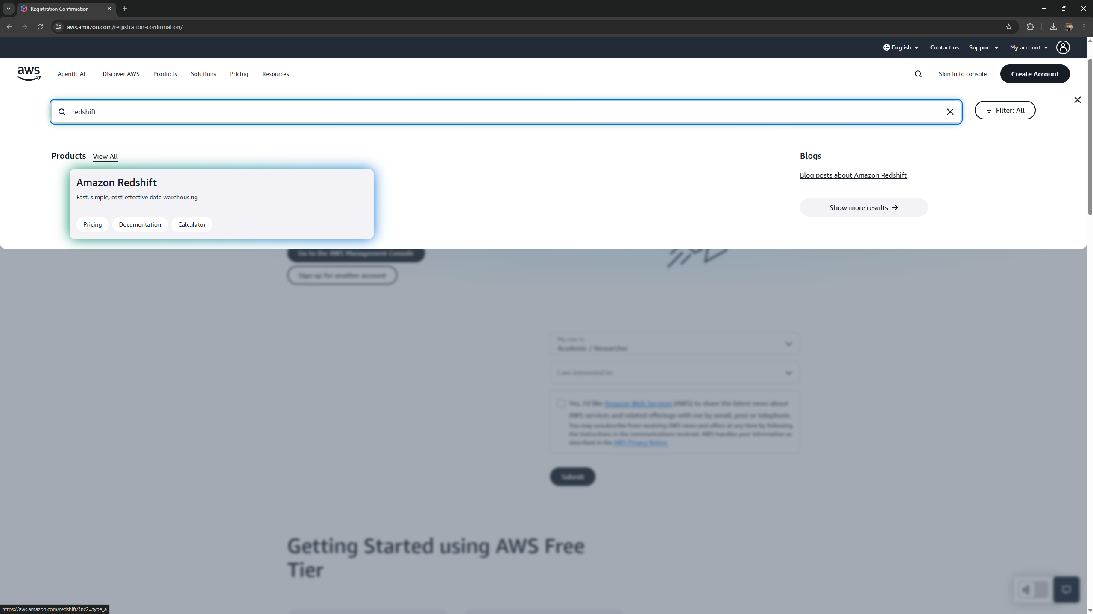

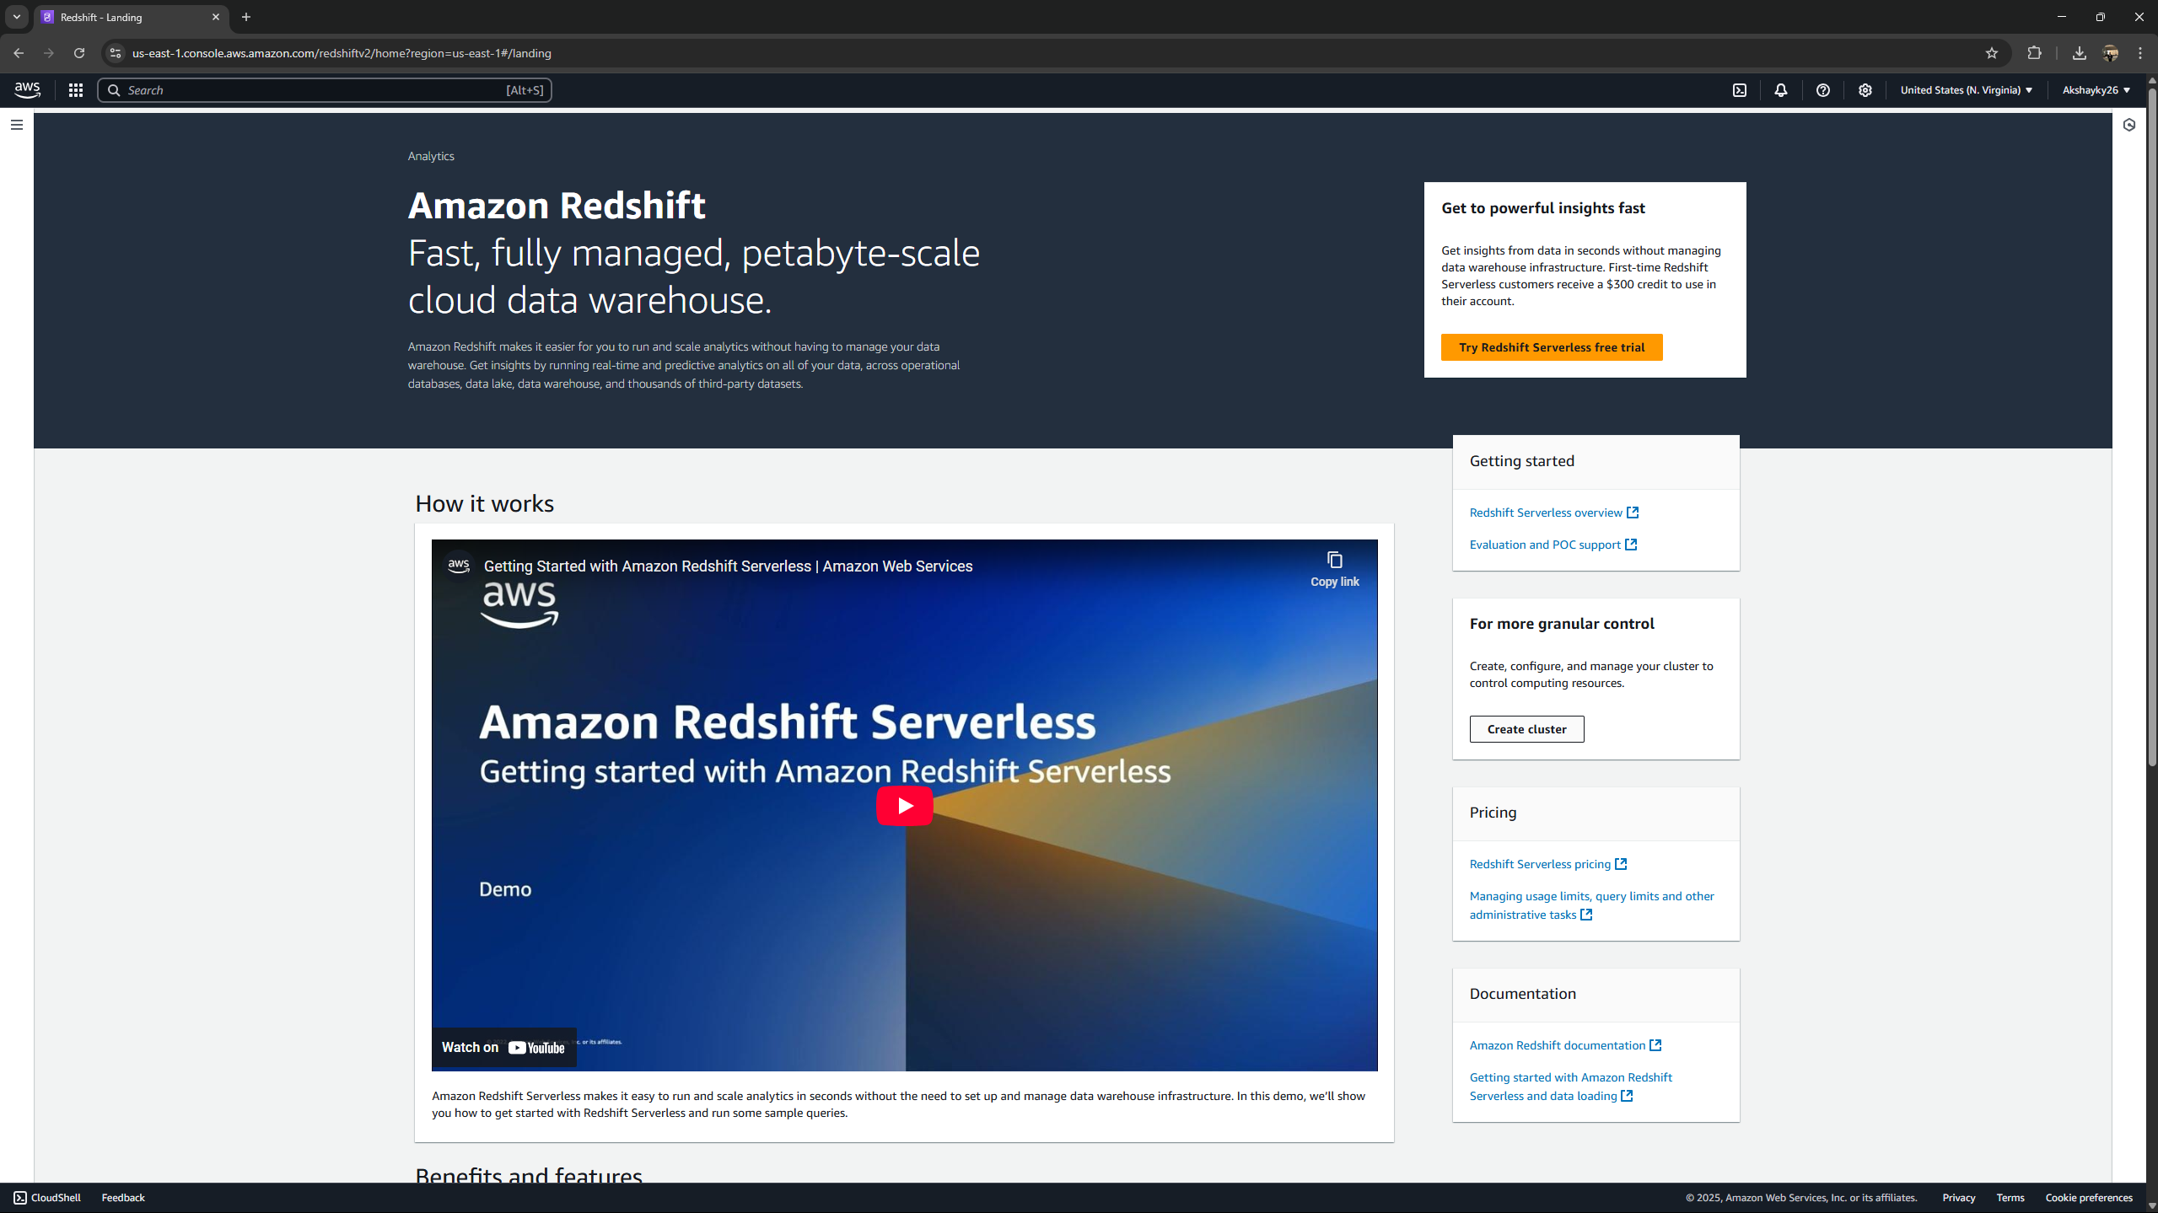

**Methods**

**connect()**

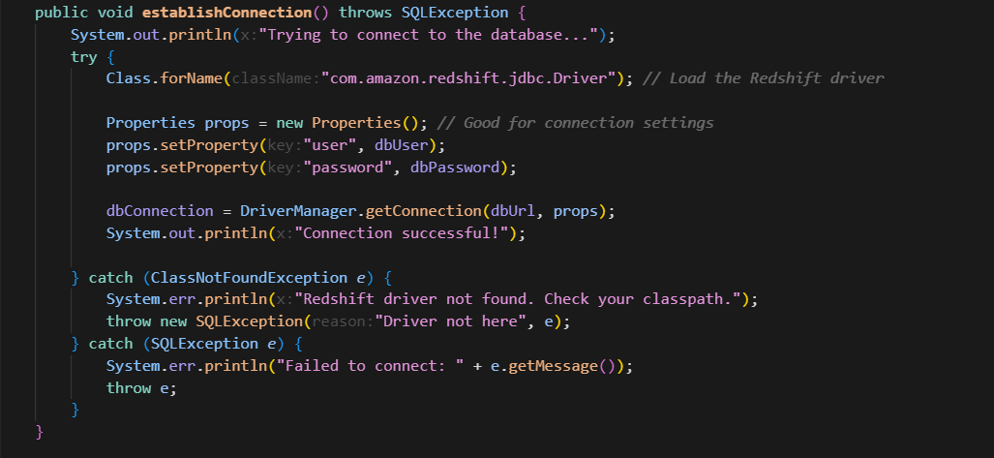

**close()**

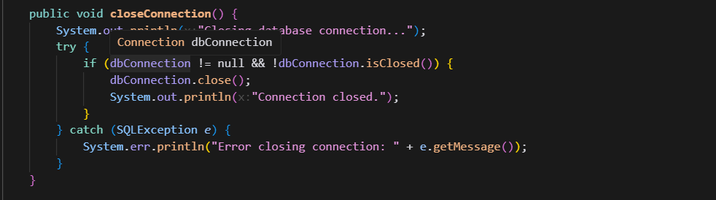

**drop()**

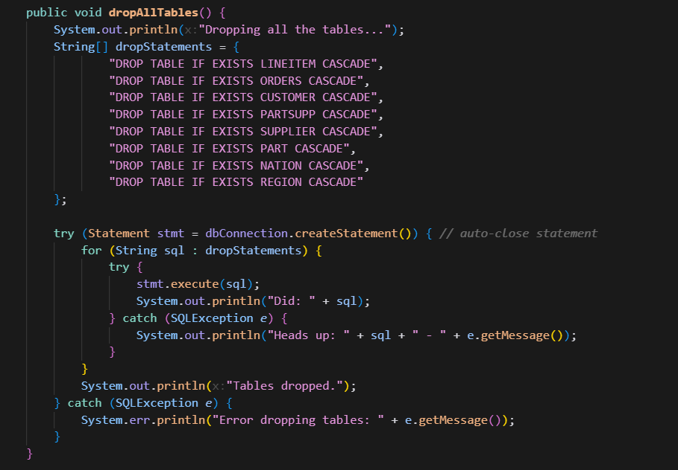

**create()**

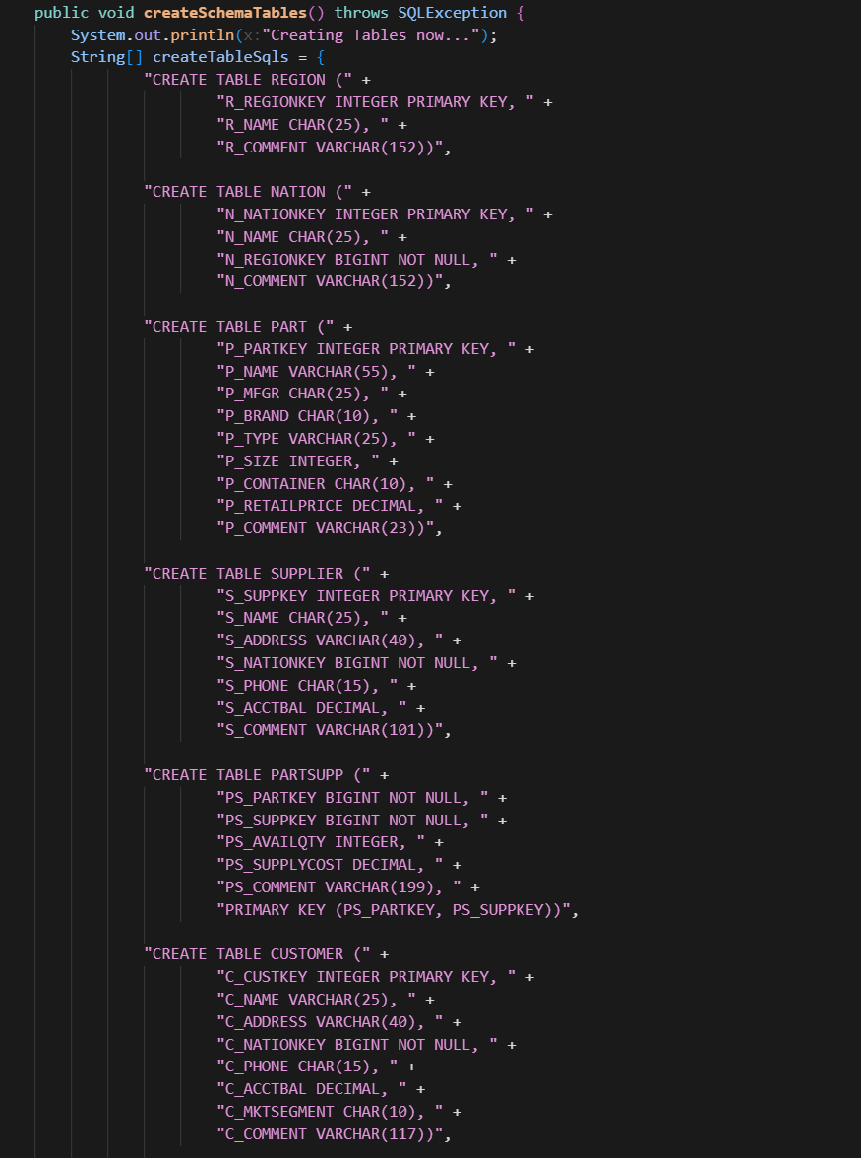

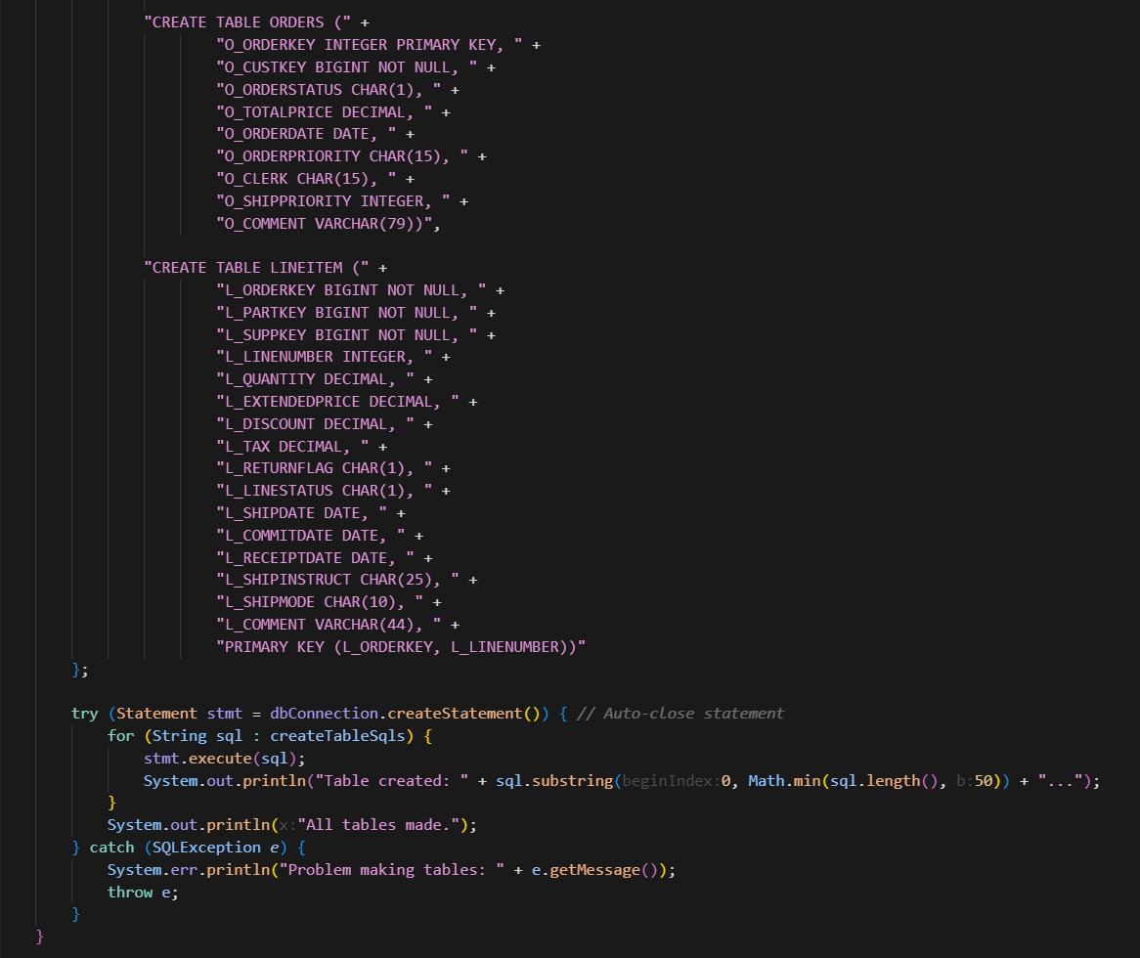

**Insert Code:** The loadTpchData() method is responsible for inserting data.

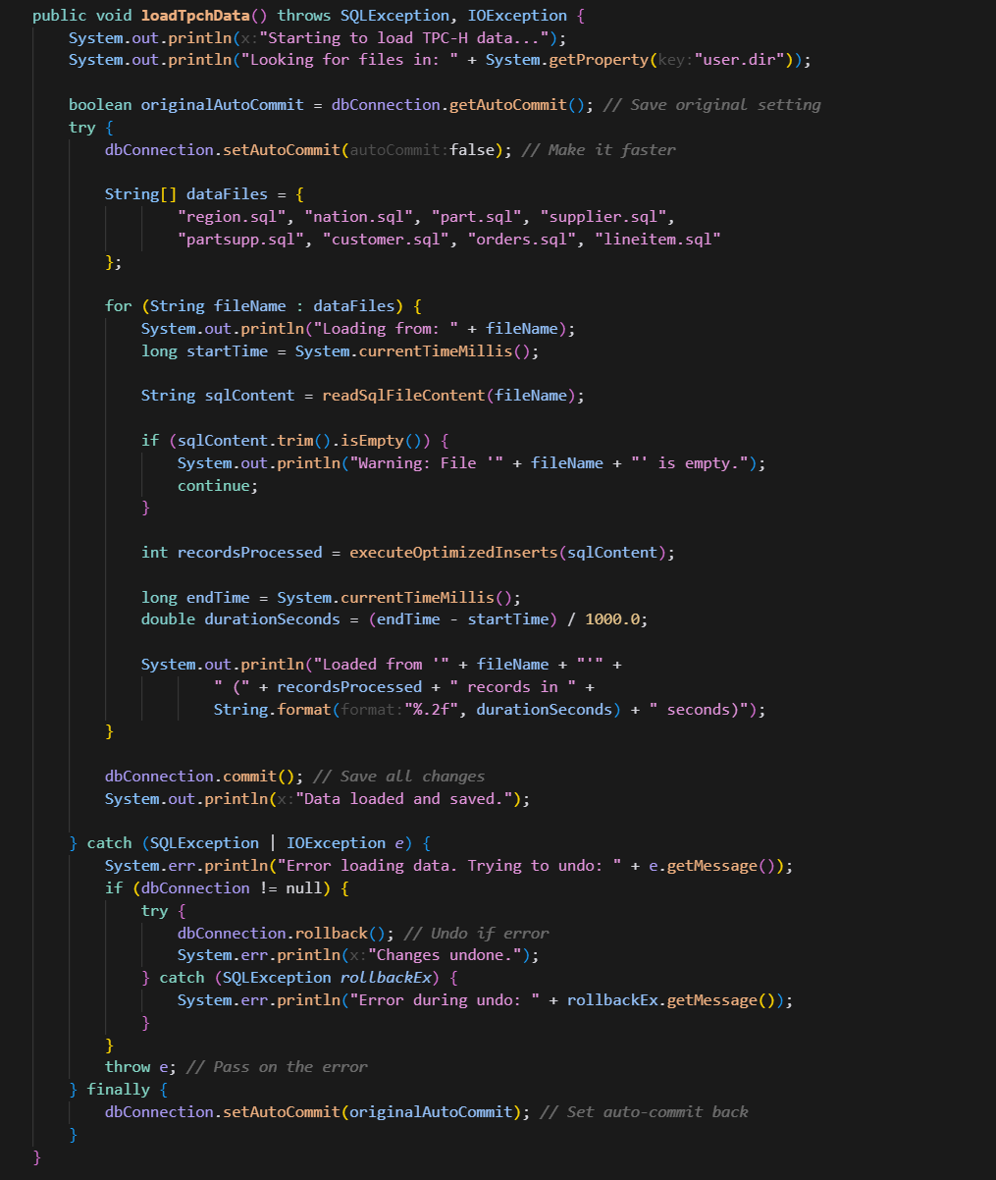

**Delete Code (Dropping Tables):** The dropAllTables() method handles deletion by executing DROP TABLE IF EXISTS statements for all the TPC-H tables.

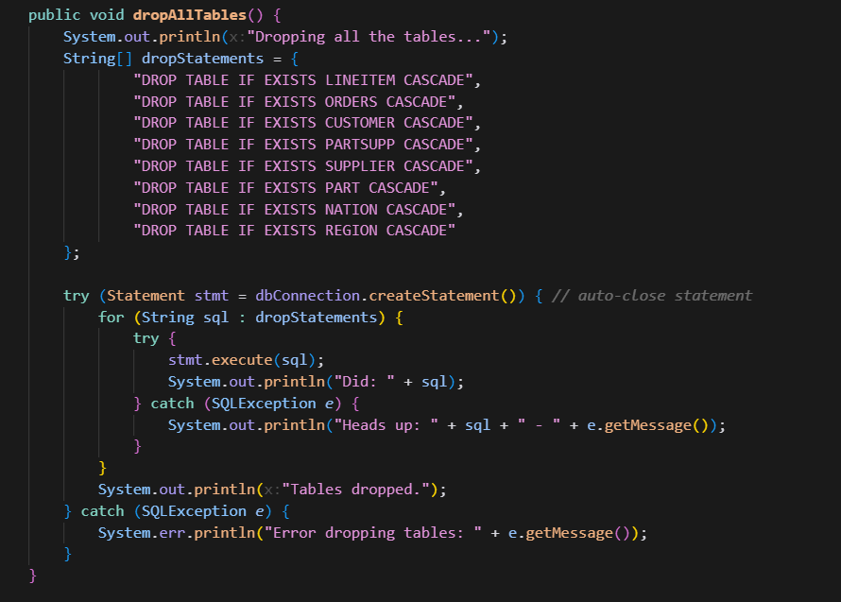

**Query1()** – Is handled by getRecentAmericanOrders()

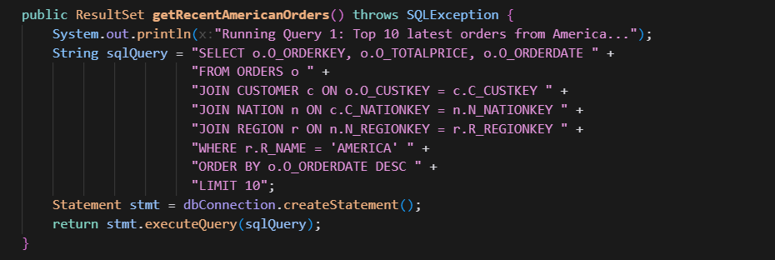

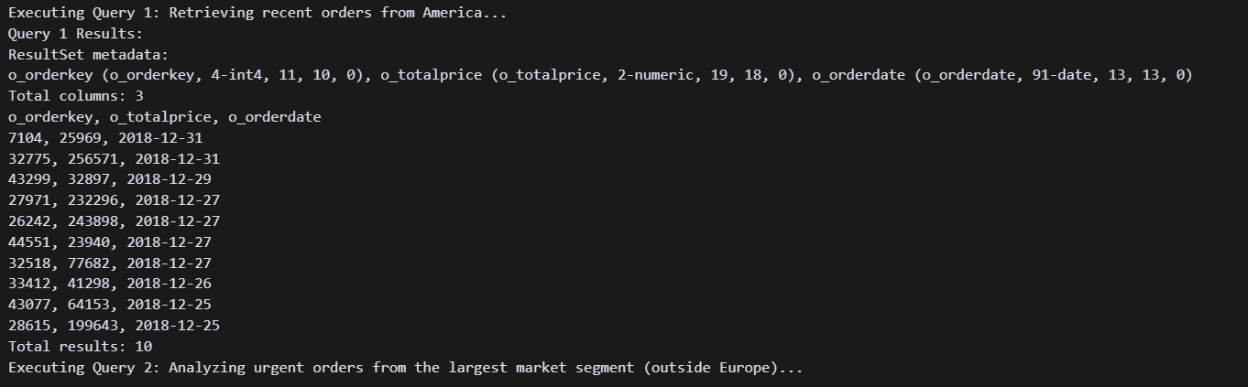

**Query2()** - This I shandled by getUrgentOrdersByLargestSegment()

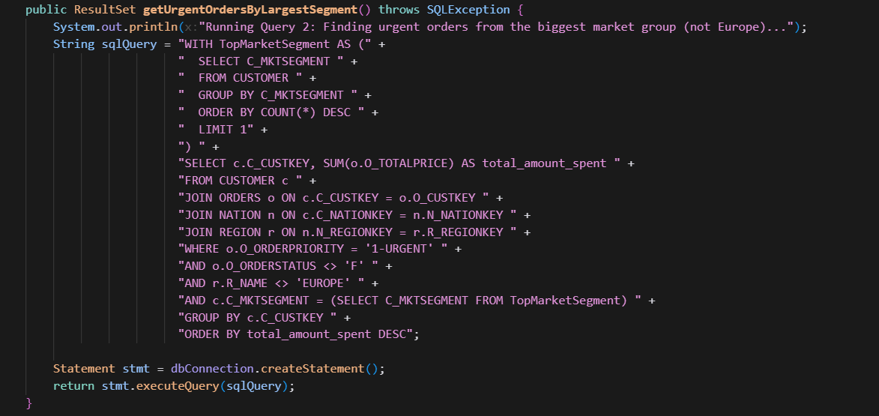

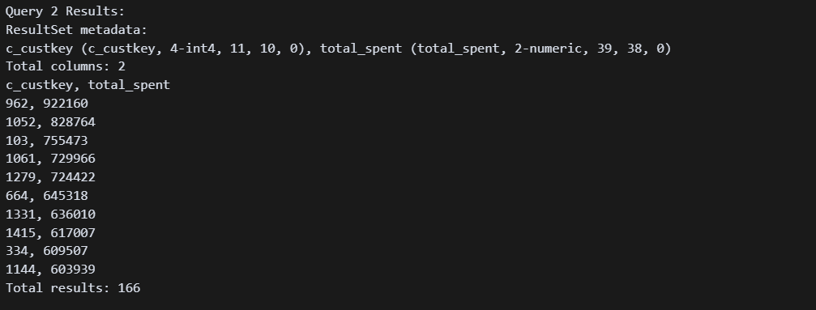

**Query3()** – This is handled by getLineItemCountsByOrderPriority()

